**Experiment 4:-**

Design a push button switch interface- door bell control.

**Circuit diagram:-**

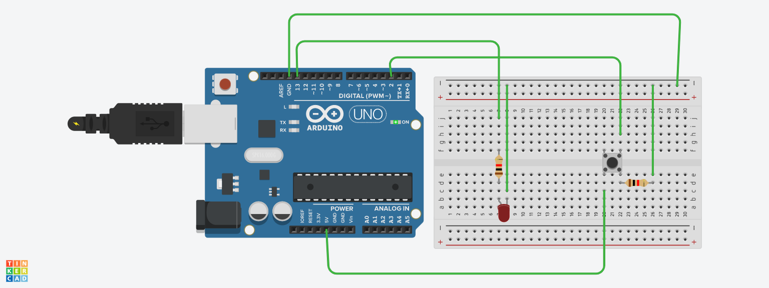

**Theory:-**

**Concept used:-**

* A push button switch is a small, sealed mechanism that completes an electric circuit when you press on it. When it's on, a small metal spring inside makes contact with two wires, allowing electricity to flow. When it's off, the spring retracts, contact is interrupted, and current won't flow.
* Momentary switches work only as long as you press on them, like the buttons on a phone, calculator or door buzzer. They can be subdivided into normally-on and normally-off types.
* Normally-Off

With the normally-off switch, there's no connection till you push the button. Most push button switches are used this way. Examples include doorbell buttons, cell phone keys and garage door openers.

* Normally-On

Here the switch conducts normally, but interrupts the circuit when you press on it. This is more specialized, and may be used in conjunction with a wiring trick. For example, connecting a normally-on switch in parallel with a light bulb will light the bulb when the button's pushed; otherwise, current will flow through the switch, leaving the bulb off.

**Learning Outcomes:-**

* I learnt about the different components in an Arduino.
* I also learnt how to connect the wires in an Arduino, and breadboard and writing the program.
* The basic importance of Arduino was known.

**Observations:-**

* When we pass electrical signals to the arduino through our code and press the push button, the buzzer buzzes and gets off accordingly.

**Problems and Troubleshooting:-**

The problems faced while doing this task are:-

* The Arduino board was not working properly.
* Connections were not tight.
* The LED was fused. I had to replace it.

**Precautions:-**

* Attach the USB cable and connecting wires carefully.
* Once the USB cable has been inserted, then the Arduino connected to the USB cable should not be touched with bare hands.